Collecting information about The Picts

Read each sentence carefully and use the words at the bottom of the page to help you fill in the blanks

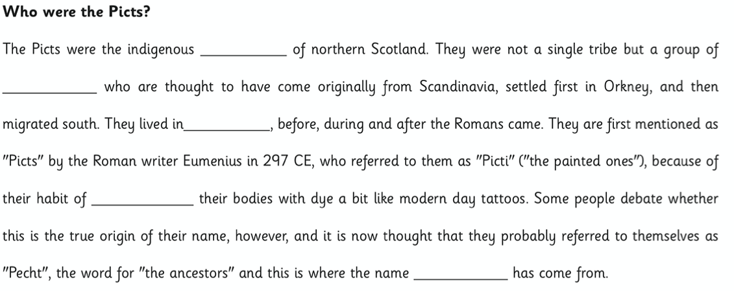

Word bank

Scotland tribe Pict people painting

Which fact did you find most interesting about The Picts?

…………………………………………………………………………………………………………………………………………..

…………………………………………………………………………………………………………………………………………..

…………………………………………………………………………………………………………………………………………..

