Nursery and Playgroup Learning (Week 01/02/2021)

Good morning everyone and we hope you have had a lovely weekend.
Start of the day – We have some new positions called Yoga moves for everyone to try today and through the week.
Rememebr to hold your positions and count to five then to ten. Try to get the grown ups to join in

Literacy – Now last week we looked at the beginning of our story called – Goldilocks and the Three Bears. First watch PowerPoint 1 which is the beginning of the story, we are revisiting this from last week. Talk about where we got up to with someone in your family. Then before looking at PowerPoint 2 – the middle part of the story talk about what you think will happen next. Try to retell the story by yourself to someone in your family. Then listen to and look at PowerPoint 3 the end of our Goldilocks and the Three Bears story.

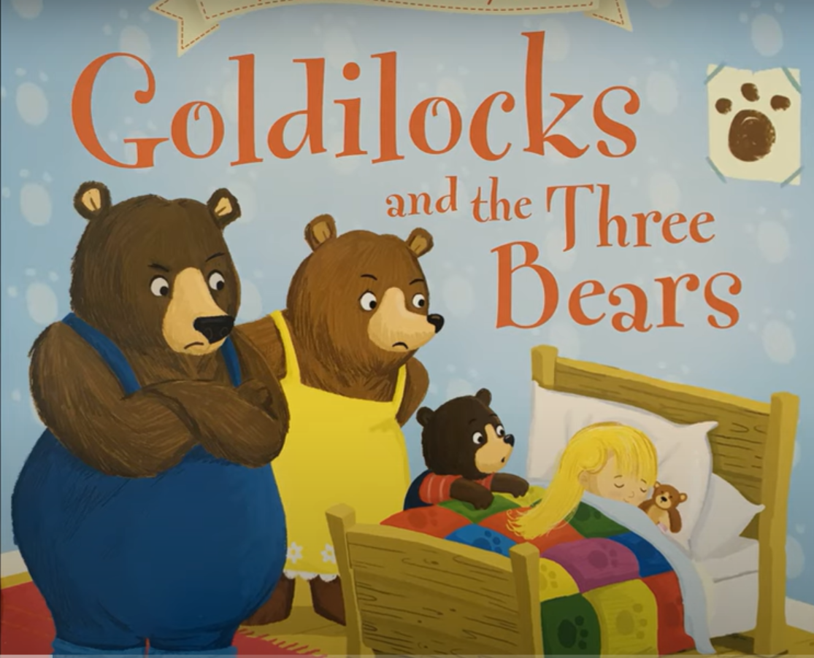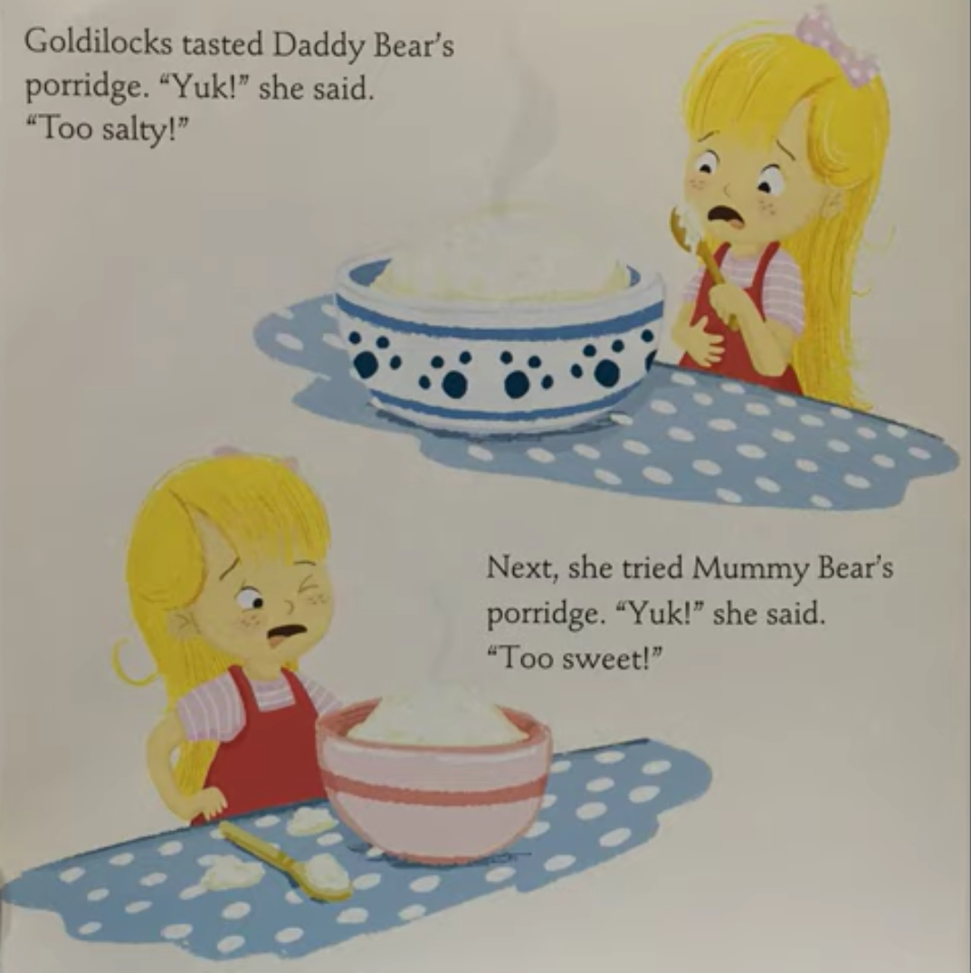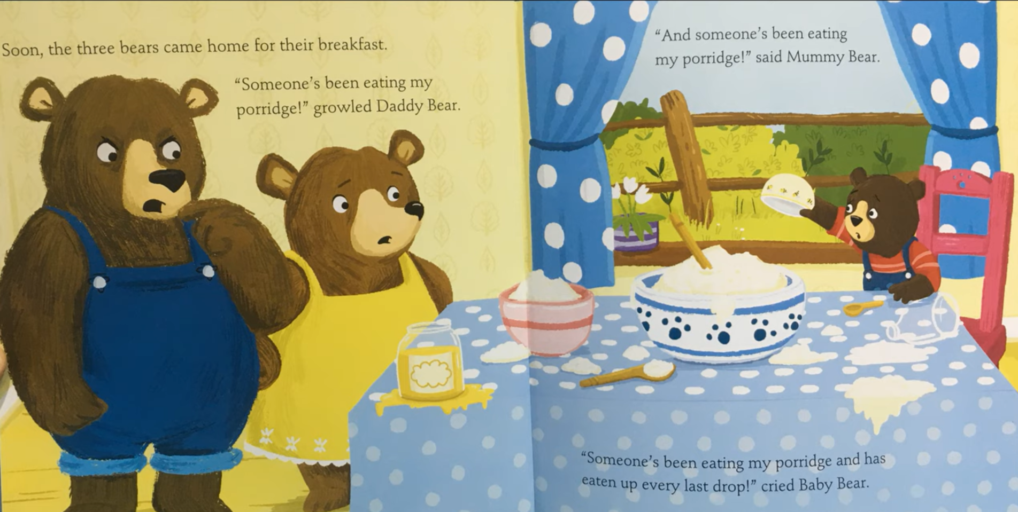
Part 1 – the beginning of the story Part 2 – the middle of the story Part 3 – the end of the story

Can you retell the story to someone in your family? Can you draw the different sized objects in the house such as the three bowls?

Handwriting patterns – Can you help Goldilocks to follow the different lines to find some things from the story? Try with your fingers first moving along the lines.

Maths
- Sing and use your fingers to help you count as you sing – Three Blind Mice
- Share the PowerPoint looking at number l
- Then share the PowerPoint looking at number 2
- We are now going to learn the song When Goldilocks went to the House of the Bears and we will learn the action to this – follow the PowerPoint then see if you can link into the this song on the BBC website.
https://www.bbc.co.uk/teach/school-radio/nursery-rhymes-when-goldilocks-went-to-the-house-of-the-bears/zbkrf4j

Songs and rhymes to learn:  After listening to When Goldilocks went to the House of The Bears stay on the website and click into the songs and rhymes. Try to put some actions into your rhymes as you sing them.  Sing these rhymes:  - Baa Baa Black Sheep  - The Wheels on the Bus – can you pretend you are on the bus in your house?  - Hickery Dickery Dock  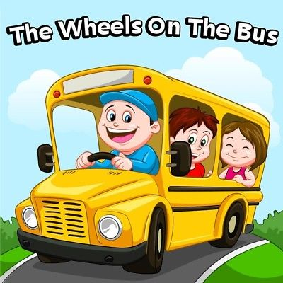  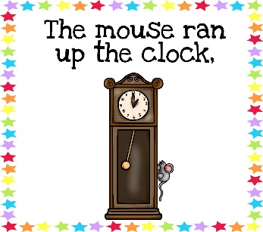 | Remember the school website is:  http://www.moorside.newcastle.sch.uk/website  If you are stuck or want to send completed work then email  linda.hall@moorside.newcastle.sch.uk  Well done everyone you are all working so hard.

