English alternative- Infer feelings

Have a look at the pictures below of the different characters from Fantastic Mr Fox.

The pictures show when the fox family heard the farmers digging into their hole.

Complete a mind map for each of the characters using the pictures shown. I have done one for you. Think about the character’s feelings and thoughts. Use these questions to help you:

* How do you think the character is feeling?
* What might the character be thinking?
* Why do you think the character is feeling this way?
* What would you be thinking if you were in this situation?
* How might you feel if you were the character?

Mr Fox

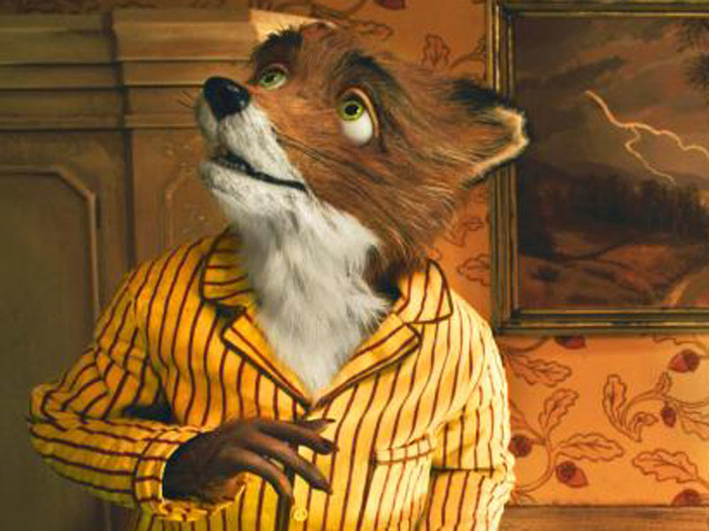

**Scared**

Mrs Fox



The children

