Which of these shapes show ¼?
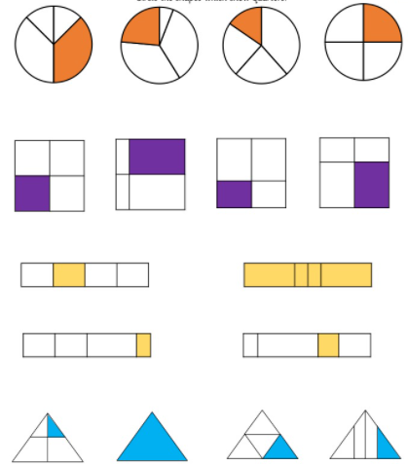

These three shapes a;; show ¼. True or false.
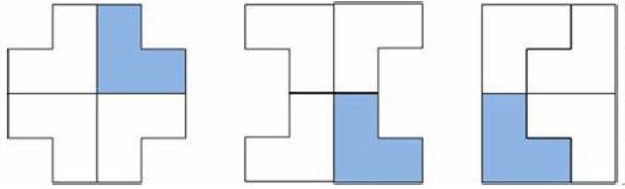

Which of these shapes has ¼ shaded?
