To use descriptive language to improve my work

Look carefully at each picture. I have labelled the two nouns, and I would like you to write a sentence to describe the picture using an adjective before each noun.

butterfly flower
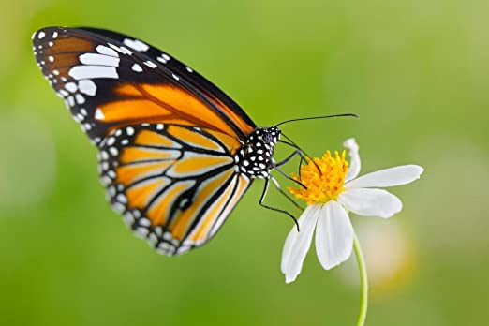

……………………………………………………………………………………………………………………………………………….

……………………………………………………………………………………………………………………………………………….

Ant leaf
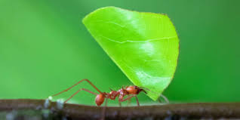

……………………………………………………………………………………………………………………………………………….

……………………………………………………………………………………………………………………………………………….

Toucan mango






