Art Learning Intention: To discuss and describe the clothing designed by Lucie Carrasco.
Look at the image of the dress designed by Lucie Carrasco. Discuss with someone what materials/fabrics have been used to make the dress.
What texture would it be? Does it have the same texture all over?
What colours have been used? Do the colours contrast? What tones of colour are used? Are they bright or dark?
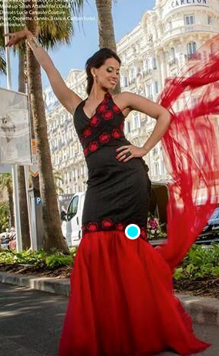
What techniques have been used to make the dress?
What is your opinion of the type of clothes that she designs? Write your answers around the image.

