27.1.21- Purple and pink reading
Look at the picture from the front cover.
Talk about what you think the story might be about?
Is it a fiction or nonfiction book?
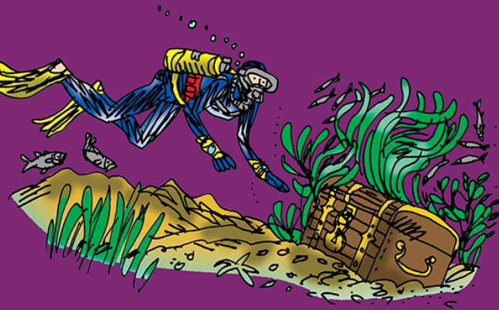

Look at the title and predict from this. 